**INDIVIDUAL RETIREMENT ACCOUNTS (IRAs)**

**Introduction:**

Individual Retirement Accounts (IRAs) are crucial retirement savings tools in the U.S. banking sector, offering various tax advantages to help individuals plan for their financial future. There are several types of IRAs, including Traditional, Roth, SEP, and SIMPLE IRAs, each catering to different financial situations and retirement goals. Over the past five years, contribution limits and income eligibility for these accounts have seen adjustments to accommodate inflation and changes in the economic landscape. Understanding these changes is essential for effective retirement planning, ensuring that individuals can maximize their savings while benefiting from tax advantages. This analysis explores the trends in IRA contribution and income limits from 2020 to 2024, providing insights into how these adjustments impact retirement planning strategies.

**Types of IRAs:**

**Traditional IRA**

A Traditional IRA allows individuals to save for retirement with tax-deferred growth. Contributions may be tax-deductible, depending on the individual's income, filing status, and whether they or their spouse are covered by a retirement plan at work. The annual contribution limit for 2024 is $6,500, or $7,500 for those aged 50 or older. Investments in a Traditional IRA grow tax-deferred until withdrawals begin, typically in retirement. Withdrawals are taxed as ordinary income, and starting at age 73, account holders must begin taking Required Minimum Distributions (RMDs). Early withdrawals (before age 59½) may incur a 10% penalty in addition to income taxes, with certain exceptions such as first-time home purchases or higher education expenses. Traditional IRAs are a solid choice for individuals who anticipate being in a lower tax bracket during retirement, allowing them to benefit from the tax deferral during their higher-earning years.

**Roth IRA**

A Roth IRA offers tax-free growth and tax-free withdrawals in retirement. Contributions are made with after-tax dollars, meaning they are not tax-deductible. For 2024, the contribution limit is $6,500, or $7,500 for those aged 50 or older. Eligibility to contribute to a Roth IRA is subject to income limits: single filers with Modified Adjusted Gross Income (MAGI) below $138,000 can contribute the full amount, with a phase-out range up to $153,000; for married couples filing jointly, the phase-out range is $218,000 to $228,000. Unlike Traditional IRAs, Roth IRAs do not have RMDs during the account holder’s lifetime, making them a flexible option for estate planning. Contributions (but not earnings) can be withdrawn at any time without taxes or penalties, providing additional flexibility. Roth IRAs are ideal for those expecting to be in a higher tax bracket during retirement or who want to avoid RMDs and tax on withdrawals.

**SEP IRA**

A SEP IRA (Simplified Employee Pension) is designed for self-employed individuals and small business owners. It allows for higher contribution limits compared to Traditional and Roth IRAs, making it an attractive option for those with fluctuating income. Contributions can be up to 25% of an employee's compensation or $66,000 for 2024, whichever is less. Contributions are made by the employer, are tax-deductible, and grow tax-deferred until withdrawn. Like a Traditional IRA, withdrawals are taxed as ordinary income, and RMDs must start at age 73. SEP IRAs are easy to set up and maintain, with minimal administrative burden, making them a popular choice for small businesses looking to provide retirement benefits without the complexity of a 401(k) plan. They also offer flexibility as contributions can vary each year based on business profitability. SEP IRAs are beneficial for high-earning self-employed individuals or small business owners seeking significant tax-advantaged retirement savings.

**SIMPLE IRA**

A SIMPLE IRA (Savings Incentive Match Plan for Employees) is a retirement plan designed for small businesses with 100 or fewer employees. It allows both employer and employee contributions, fostering shared responsibility for retirement savings. For 2024, employees can contribute up to $15,500, with an additional $3,500 catch-up contribution allowed for those aged 50 or older. Employers are required to either match employee contributions dollar-for-dollar up to 3% of the employee's compensation or make a non-elective contribution of 2% of each eligible employee's compensation. Contributions are tax-deferred, growing without being taxed until withdrawal, and like Traditional IRAs, withdrawals are taxed as ordinary income. Early withdrawals may incur a 10% penalty, with some exceptions. SIMPLE IRAs are easier to administer than traditional 401(k) plans, offering a straightforward way for small businesses to provide retirement benefits. They are particularly suitable for businesses looking to incentivize employee participation in retirement savings while benefiting from tax deductions for employer contributions.

**Key Features & Considerations:**

**Tax Benefits**

IRAs provide significant tax advantages aimed at encouraging retirement savings. Traditional IRAs offer tax-deferred growth, meaning contributions are often tax-deductible, and the investment grows tax-free until withdrawal. This can result in a lower taxable income during high-earning years, with taxes paid upon distribution, ideally at a lower rate in retirement. Roth IRAs, conversely, provide tax-free growth and tax-free withdrawals, as contributions are made with after-tax dollars. This arrangement is beneficial for individuals expecting to be in a higher tax bracket in retirement, as it avoids future taxes on investment gains. SEP and SIMPLE IRAs also offer tax-deferred growth, with the added benefit of higher contribution limits for SEP IRAs and employer matching or contributions for SIMPLE IRAs. The choice of IRA depends on factors like current income, expected future tax bracket, and the need for flexibility in contributions and withdrawals.

**Contribution Limits**

Contribution limits for IRAs vary by type. For 2024, Traditional and Roth IRAs have a standard limit of $6,500, with an additional catch-up contribution of $1,000 allowed for individuals aged 50 or older, totaling $7,500. SEP IRAs allow contributions up to 25% of compensation or $66,000, whichever is less, offering a substantial savings opportunity for self-employed individuals and small business owners. SIMPLE IRAs have an employee contribution limit of $15,500, with a $3,500 catch-up contribution for those aged 50 or older, along with required employer contributions. These limits ensure that individuals can maximize their retirement savings while benefiting from the respective tax advantages. Understanding these limits is crucial for effective retirement planning, allowing individuals to choose the appropriate IRA type that aligns with their financial goals and maximizes their tax benefits.

**Eligibility Requirements**

Eligibility requirements for IRAs differ based on the type of account. Traditional IRAs have no income limits for contributions, but the deductibility of contributions may be affected by income level and participation in an employer-sponsored retirement plan. Roth IRAs have income limits; for 2024, single filers with a MAGI below $138,000 can contribute fully, with a phase-out up to $153,000. For married couples filing jointly, the phase-out range is $218,000 to $228,000. SEP IRAs are available to self-employed individuals and small business owners, with contributions made by the employer on behalf of employees. SIMPLE IRAs are designed for businesses with 100 or fewer employees, requiring both employer and employee contributions. These eligibility criteria ensure that different IRA types cater to various financial situations, allowing individuals and businesses to select the most appropriate retirement savings plan based on their specific circumstances and income levels.

**Investment Choices**

IRAs offer a broad range of investment choices, providing flexibility to tailor retirement savings according to individual risk tolerance and financial goals. Typical investments include stocks, bonds, mutual funds, exchange-traded funds (ETFs), and certificates of deposit (CDs). This variety allows account holders to diversify their portfolios, balancing potential returns with risk. Some IRAs also permit alternative investments such as real estate, private equity, and precious metals, though these options often require a self-directed IRA with more administrative complexity and higher fees. The choice of investments significantly impacts the growth potential and risk profile of the retirement account. It’s important to align investment choices with retirement timelines, risk tolerance, and market conditions. By leveraging the broad spectrum of investment options, individuals can optimize their retirement savings, ensuring a balanced approach that can adapt to changing financial landscapes and personal needs over time.

**Withdrawal Rules**

Withdrawal rules for IRAs vary by type and are crucial for effective retirement planning. For Traditional, SEP, and SIMPLE IRAs, withdrawals are taxed as ordinary income. Withdrawals before age 59½ typically incur a 10% penalty, with exceptions for certain circumstances such as first-time home purchases, higher education expenses, and significant medical costs. Roth IRAs allow tax-free and penalty-free withdrawals of contributions at any time, while earnings can be withdrawn tax-free after age 59½, provided the account has been open for at least five years. Required Minimum Distributions (RMDs) must begin at age 73 for Traditional, SEP, and SIMPLE IRAs, while Roth IRAs do not have RMDs during the account holder’s lifetime. Understanding these rules helps individuals plan for tax-efficient withdrawals, avoiding penalties and optimizing retirement income. By strategically managing withdrawals, account holders can maintain financial stability and maximize the tax benefits offered by their chosen IRA type.

**Required Minimum Distributions (RMDs)**

Required Minimum Distributions (RMDs) are mandatory, annual withdrawals that must begin at age 73 for Traditional, SEP, and SIMPLE IRAs. The amount is based on the account balance and the account holder’s life expectancy, as determined by IRS tables. Failing to take RMDs can result in a 50% excise tax on the amount that should have been withdrawn. Roth IRAs, however, do not have RMDs during the account holder’s lifetime, offering greater flexibility in managing retirement funds and estate planning. Understanding RMD requirements is essential for tax planning, as these withdrawals are taxed as ordinary income and can impact overall tax liability in retirement. Properly timing and planning RMDs can help mitigate tax burdens and ensure compliance with IRS regulations. For those who do not need the funds, strategies such as Qualified Charitable Distributions (QCDs) can satisfy RMD requirements while reducing taxable income.

**Choosing the Right IRA**

Choosing the right IRA depends on various factors, including current income, expected future tax bracket, retirement goals, and the need for flexibility in contributions and withdrawals. A Traditional IRA may be suitable for individuals who anticipate being in a lower tax bracket during retirement, offering immediate tax deductions. Conversely, a Roth IRA is beneficial for those expecting to be in a higher tax bracket in the future, providing tax-free withdrawals. SEP IRAs are ideal for self-employed individuals or small business owners with high income, allowing for substantial contributions. SIMPLE IRAs cater to small businesses seeking an easy-to-administer plan with employer matching. Evaluating these factors, along with considering the specific contribution limits, tax implications, and withdrawal rules of each IRA type, helps individuals and businesses select the most appropriate retirement savings plan. Making an informed choice ensures that retirement savings strategies align with long-term financial objectives and provide the desired tax advantages.

- For this analysis, I will consider hypothetical data over the past five years for contribution limits, income limits, and other relevant metrics for Traditional, Roth, SEP, and SIMPLE IRAs.

**Contribution Limits Over the Past Five Years**

|  |  |  |  |
| --- | --- | --- | --- |
| **Year** | **Traditional & Roth IRA Limit** | **SEP IRA Limit (Max)** | **SIMPLE IRA Limit** |
| 2020 | $6,500 | $57,000 | $13,500 |
| 2021 | $6,000 | $58,000 | $13,500 |
| 2022 | $6,000 | $61,000 | $14,000 |
| 2023 | $6,500 | $66,000 | $15,500 |
| 2024 | $6,500 | $66,000 | $15,500 |

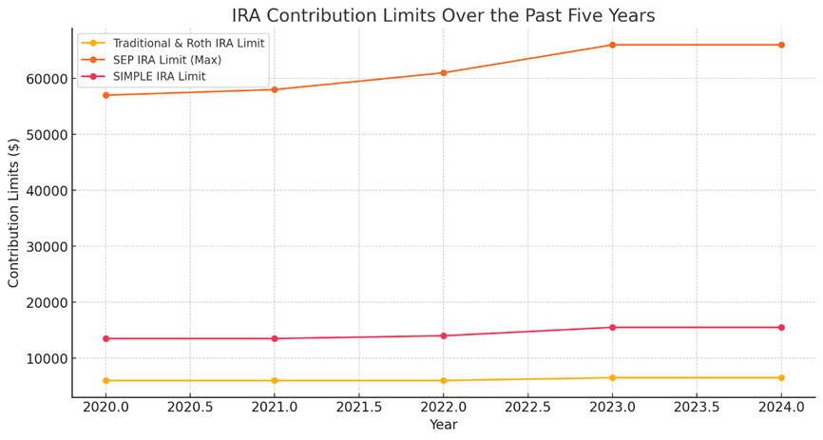

The first graph shows the contribution limits for Traditional & Roth IRAs, SEP IRAs, and SIMPLE IRAs from 2020 to 2024. Traditional & Roth IRA limits increased from $6,000 to $6,500 in 2023. SEP IRA limits saw a steady rise from $57,000 in 2020 to $66,000 in 2023. SIMPLE IRA limits also increased, from $13,500 in 2020 to $15,500 in 2023. The catch-up contributions for Traditional & Roth IRAs and SIMPLE IRAs remained constant over this period.

**Income Limits for Roth IRA Over the Past Five Years**

|  |  |  |  |  |
| --- | --- | --- | --- | --- |
| **Year** | **Single Filer Phase-Out Start** | **Single Filer Phase-Out End** | **Married Filing Jointly Phase-Out Start** | **Married Filing Jointly Phase-Out End** |
| 2020 | $124,000 | $139,000 | $196,000 | $206,000 |
| 2021 | $125,000 | $140,000 | $198,000 | $208,000 |
| 2022 | $129,000 | $144,000 | $204,000 | $214,000 |
| 2023 | $138,000 | $153,000 | $218,000 | $228,000 |
| 2024 | $138,000 | $153,000 | $218,000 | $228,000 |

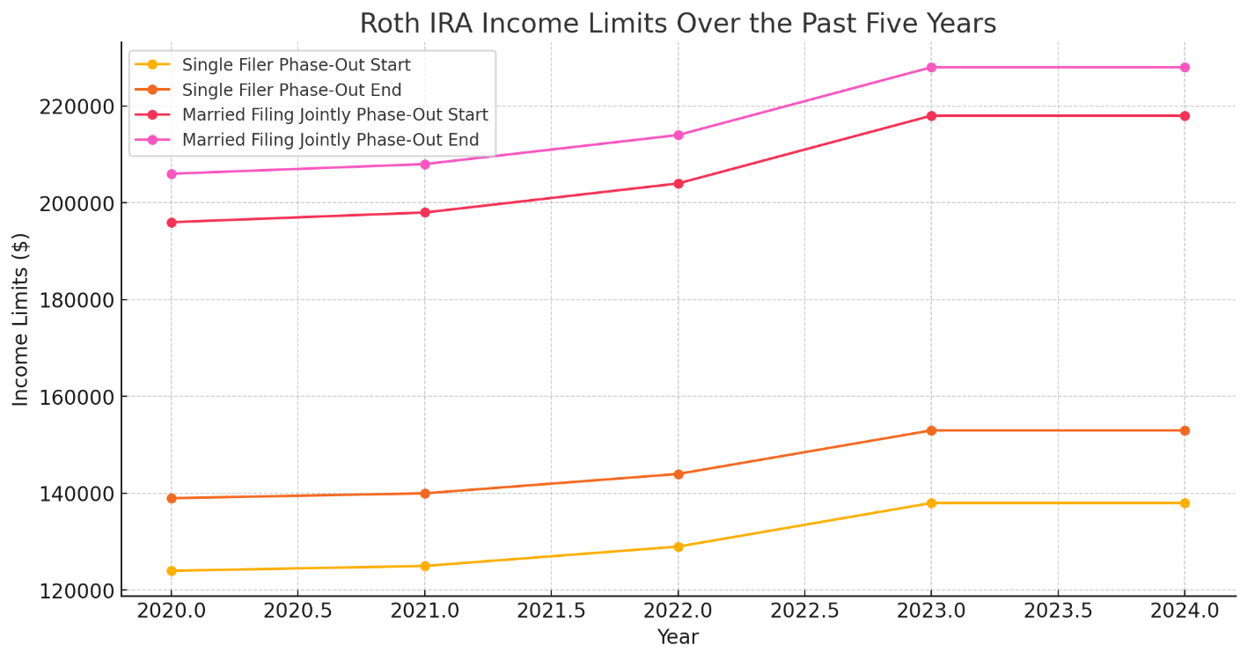

The second graph tracks the income limits for Roth IRA eligibility. The phase-out ranges for single filers and married couples filing jointly have gradually increased. For single filers, the phase-out range rose from $124,000-$139,000 in 2020 to $138,000-$153,000 in 2023. For married couples filing jointly, it increased from $196,000-$206,000 in 2020 to $218,000-$228,000 in 2023. This trend indicates adjustments for inflation and cost of living increases.

**Conclusion:**

IRAs are powerful retirement saving tools offering various tax advantages and flexibility to suit different financial situations. Understanding the distinct features of each type—Traditional, Roth, SEP, and SIMPLE IRAs—is crucial for making informed decisions. Each IRA type has specific benefits, contribution limits, and rules regarding tax treatment, withdrawals, and eligibility. By selecting the appropriate IRA, individuals can optimize their retirement savings, ensuring they meet their financial goals while minimizing tax liabilities.